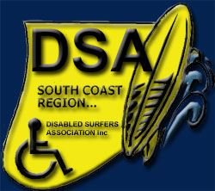
Disabled Surfers
South Coast
Presents
Gerroa ‘Smiles on Dials Day’
Sunday 27th March 2022
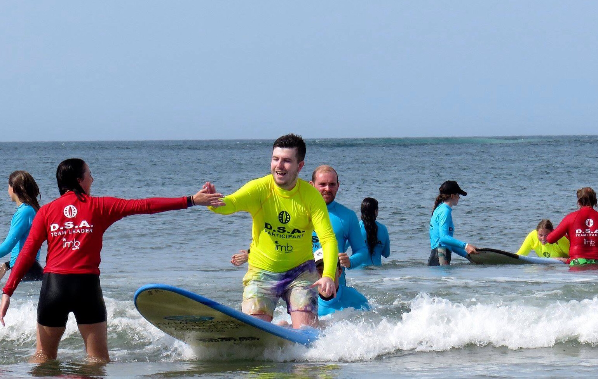
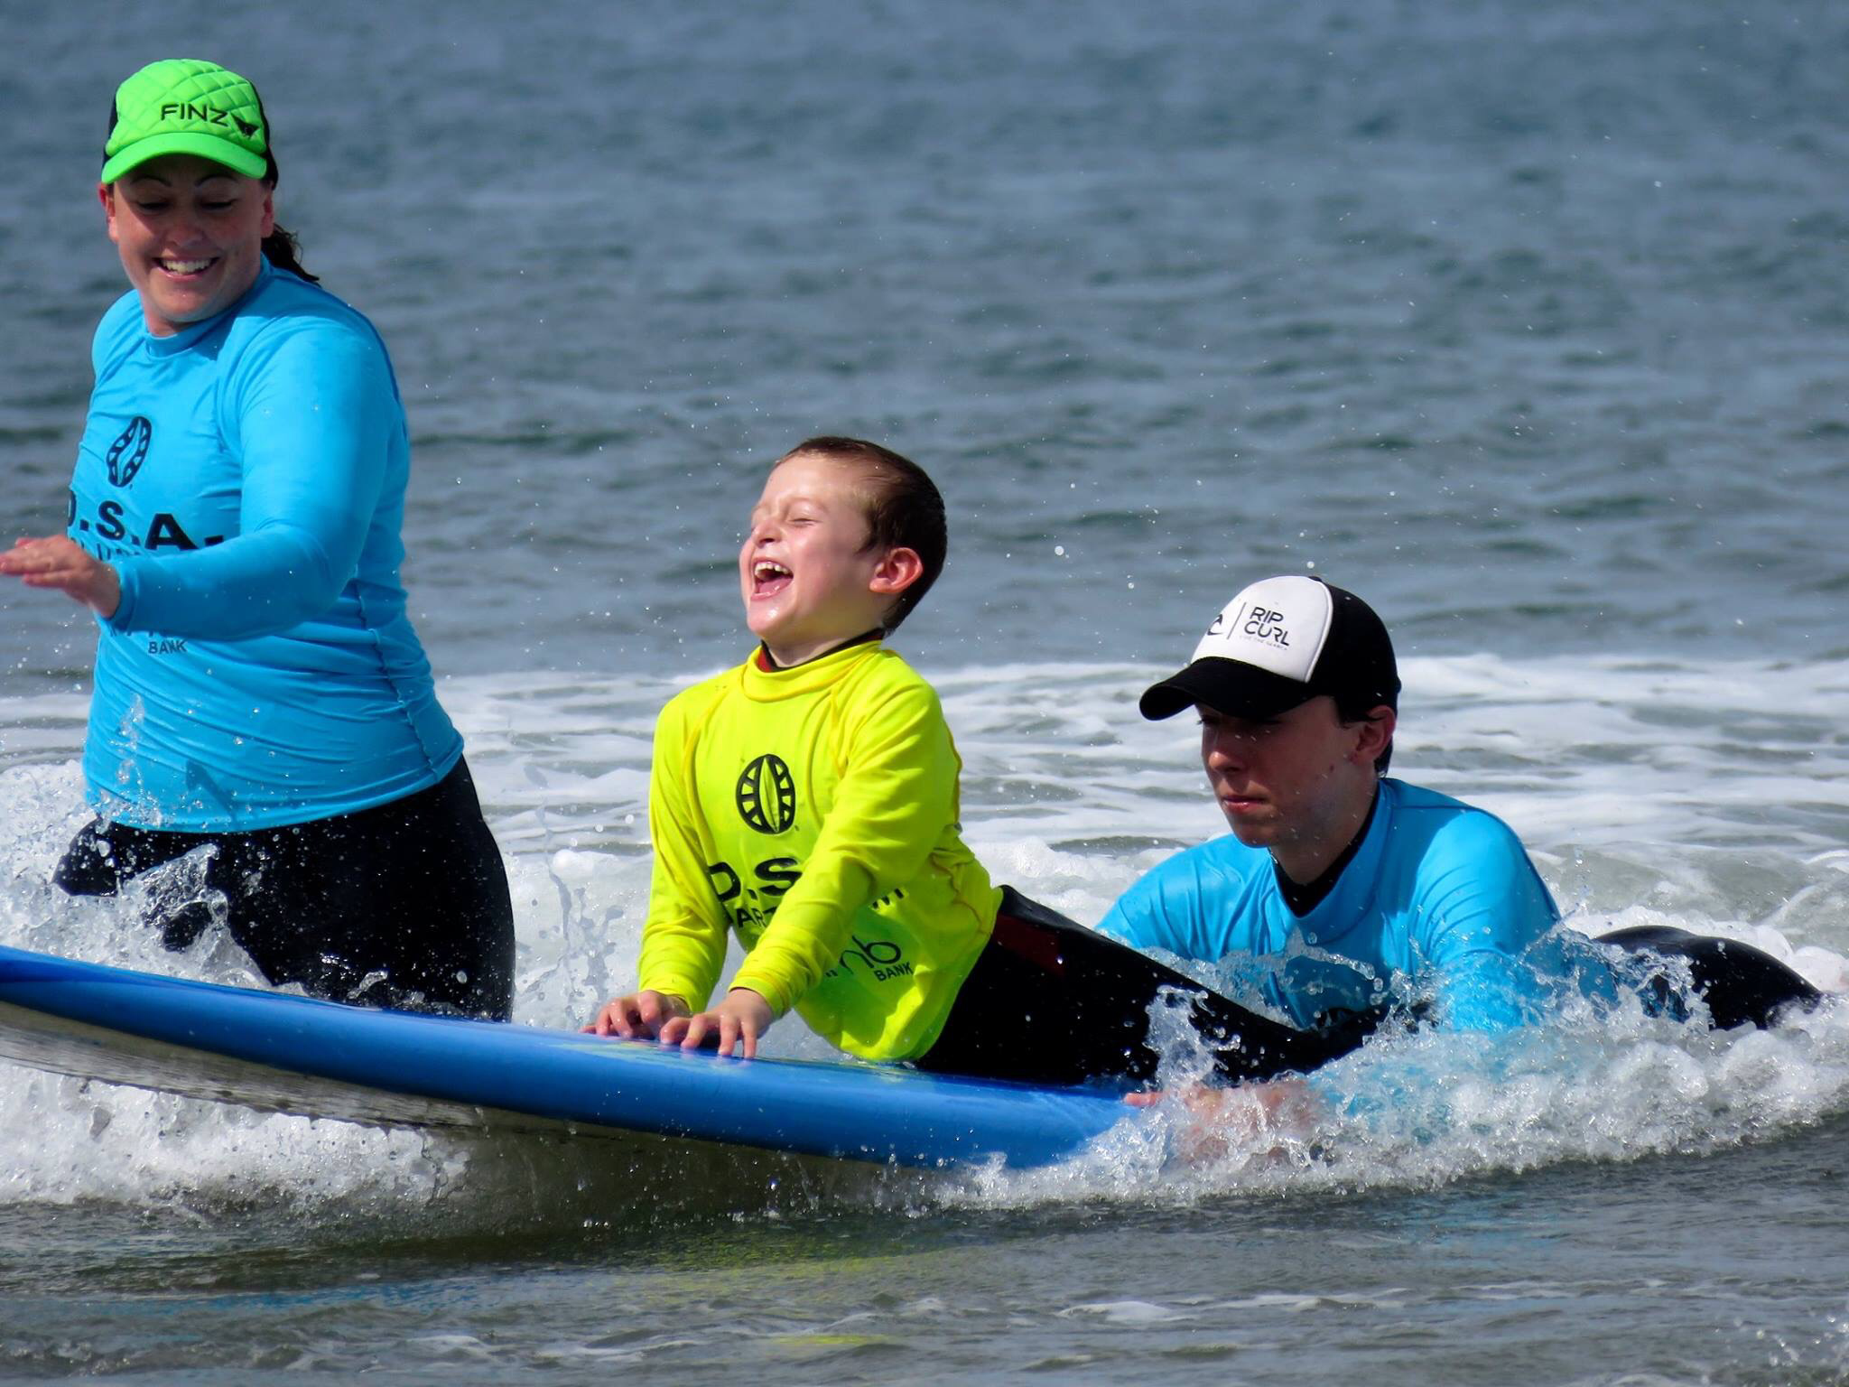
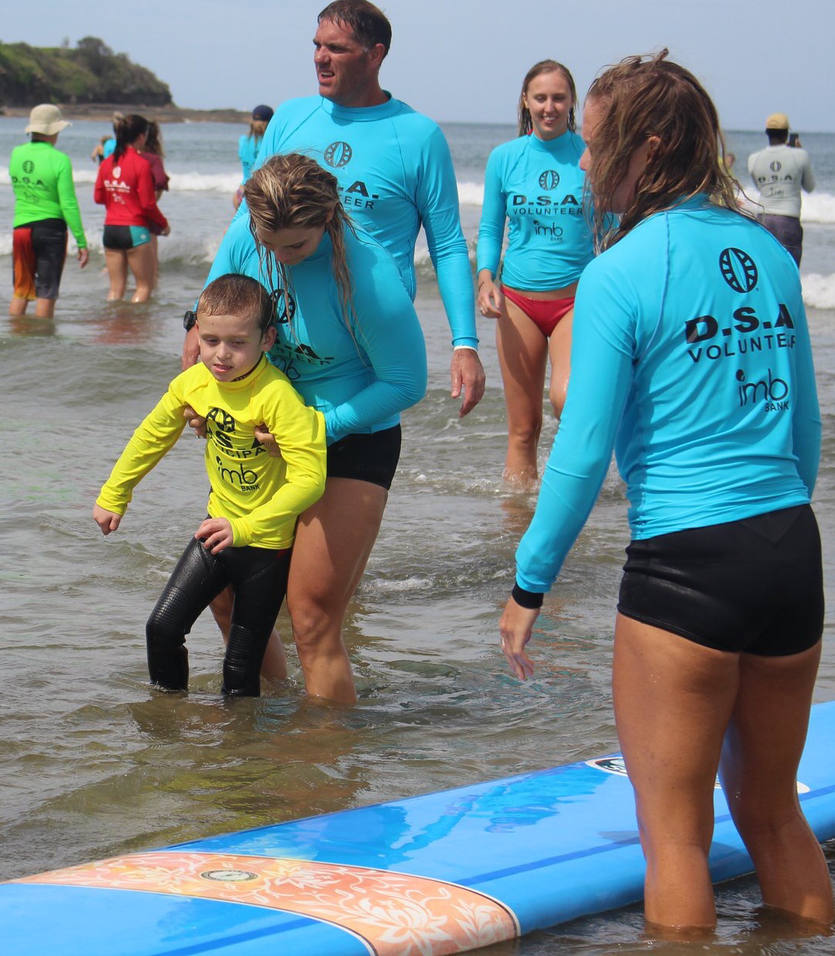
Meet at Emery Park, just off Riverleigh Ave and Park Rd, Gerroa
Check-in no later than 9.00am -
To assist us with numbers If you could register through Eventbrite. www.eventbrite.com.au
Gerroa - DSA South Coast - Disabled Surfers Association Tickets, Sun 27/03/2022 at 9:00 am | Eventbrite
Group-care facility participants limit of 6 per facility.
A fun day surfing experience for any person with a disability, no matter how challenging, with complete water supervision.

Registration for Participants is Free as it is with volunteers.
Thanks to the local participating surf shops and businesses some gifts are provided.

NSW Health Covid restrictions apply
Please do not attend if | Please
You are feeling unwell. | Follow Social distancing where possible
Are awaiting a Covid Test | Use hand sanitizer (available on site)
Have recently received a positive covid test | Use a mask when out of the water and in groups (optional)
Have been a close contact to a positive test | Masks are not required due to this being an outdoors event, but appreciated for the safety of all

Or for more information and who to contact view
disabledsurfers.org/nsw/south-coast-branch or www.disabledsurfers.org

